Assignment - 2
Name - Atish Kadam
Roll - CS25MTECH14003

*I have captured my own traces

Question 1.
Ans -
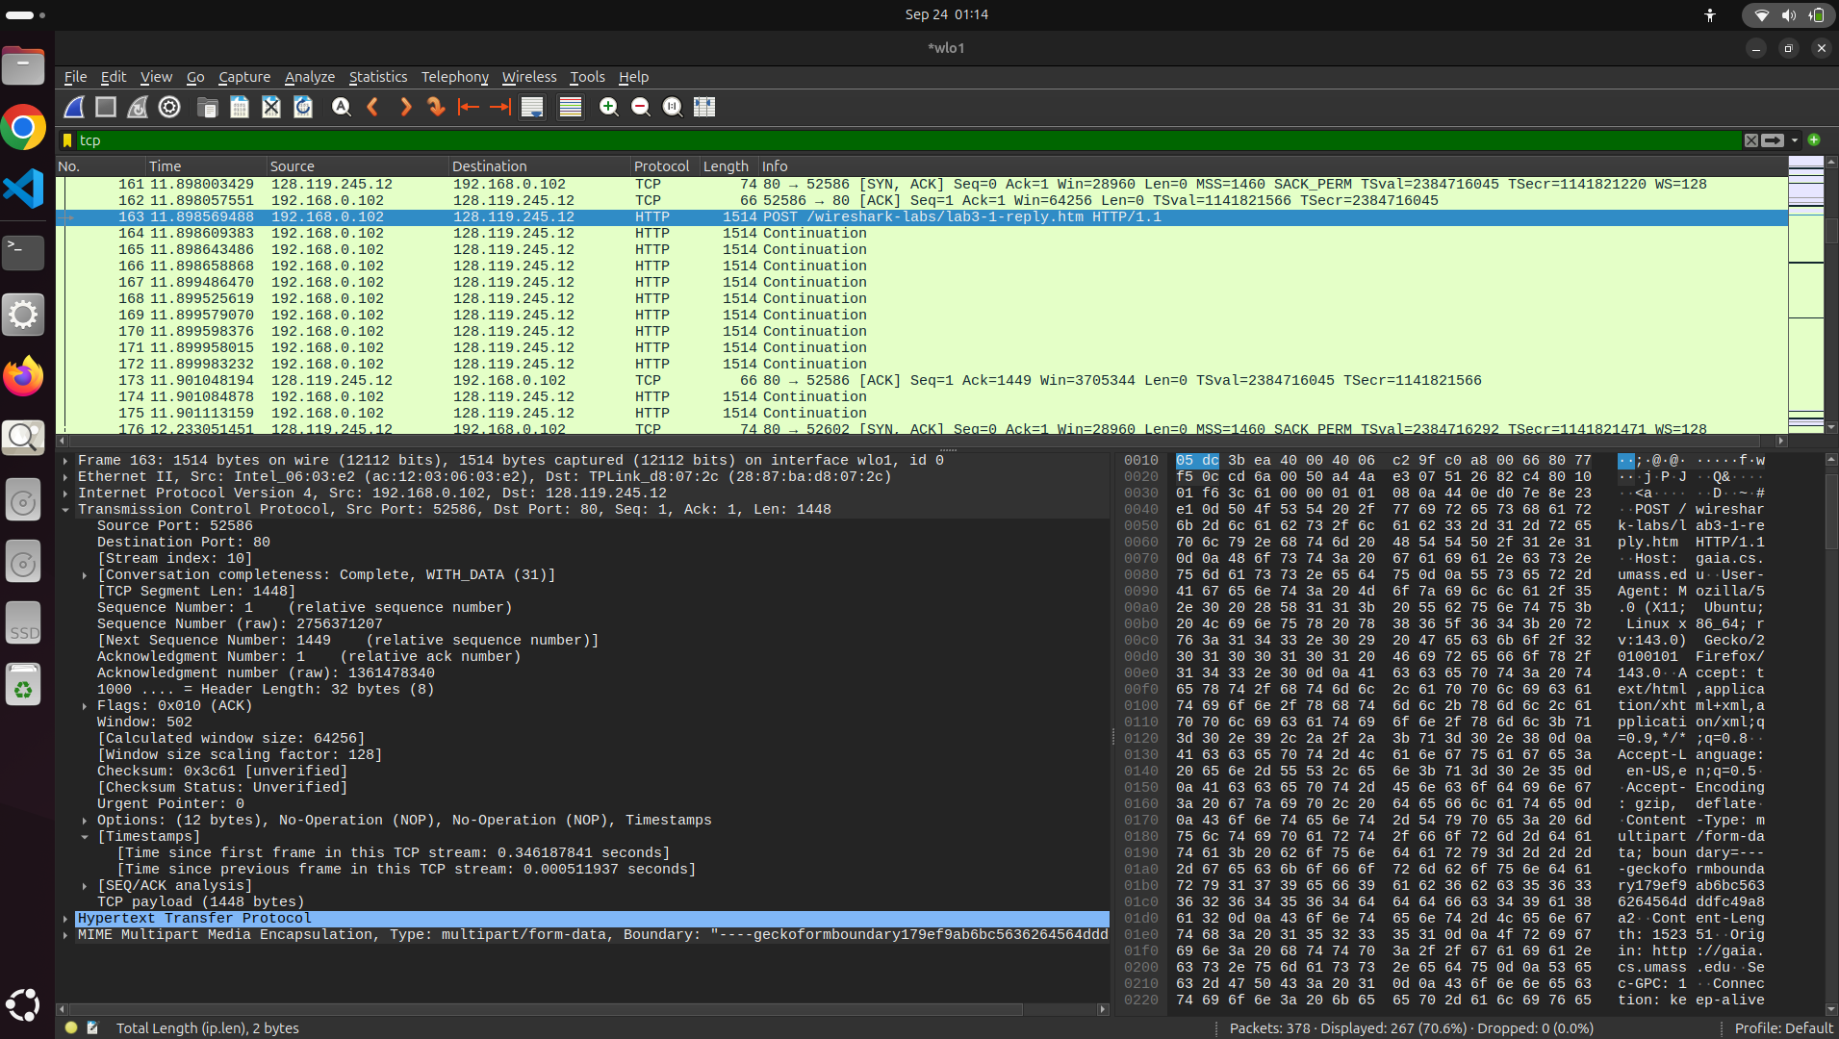
Sender (Source Computer)
IP Address - 192.168.0.102
TCP Port No - 52586

Question 2.
Ans - 
Receiver (gain.cs.umass.edu)
IP Address - 128.119.245.12
TCP Port No - 80

Question 3.
Ans -
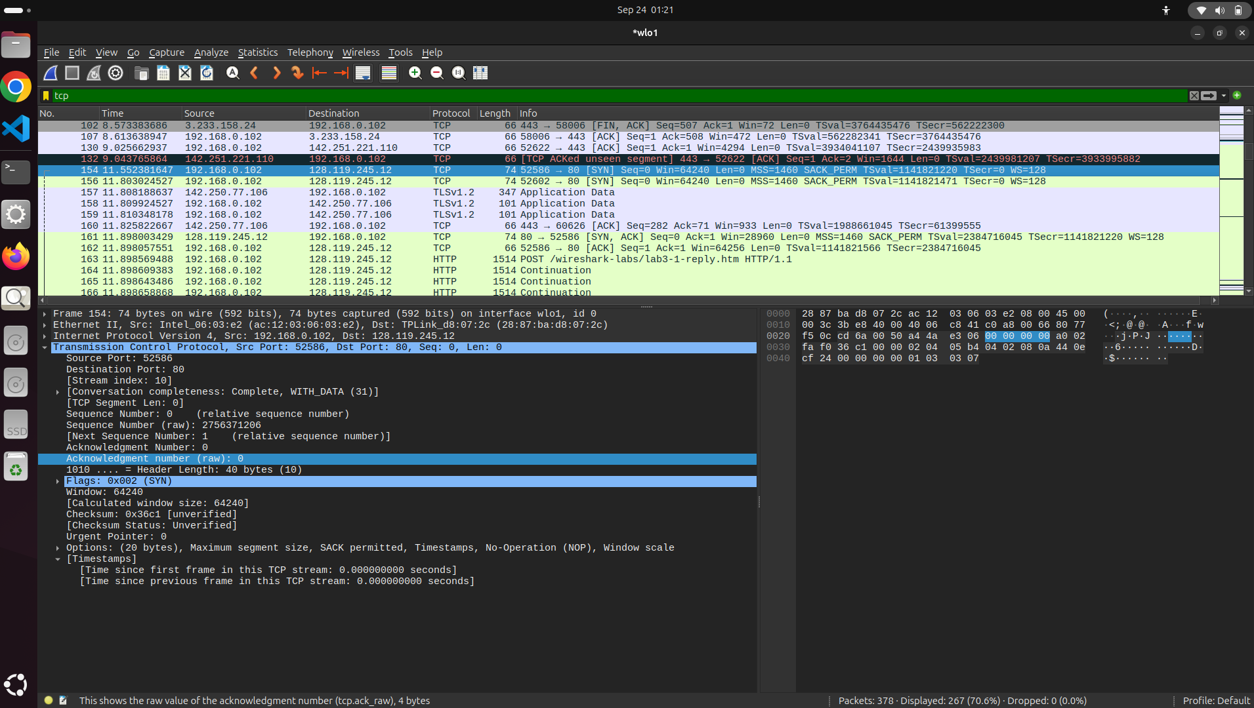
TCP SYN segment - (From Sender to reciever)
Sequence Number = 0 (Used by wireshark)
Sequence Number (raw) = 2756371206 (Sender add this to TCP Header)

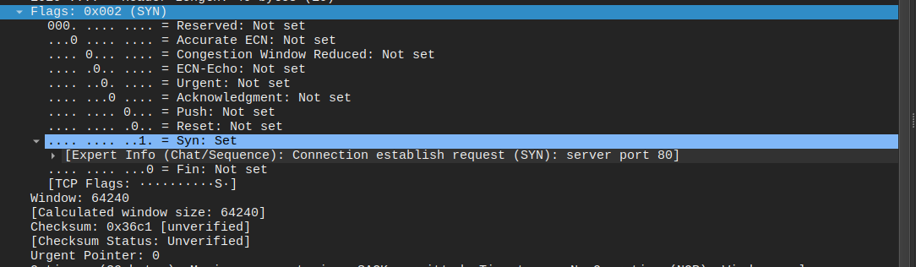
In TCP Header,
We have Flags fields (SYN,ACK,FIN,RST,PSH,URG,ECE,CWR) that defines the purpose of the given segment.
In this case we are getting
Flag -
Flags = 0x002 (SYN)
Which tells that this segment is used for starting TCP connection.
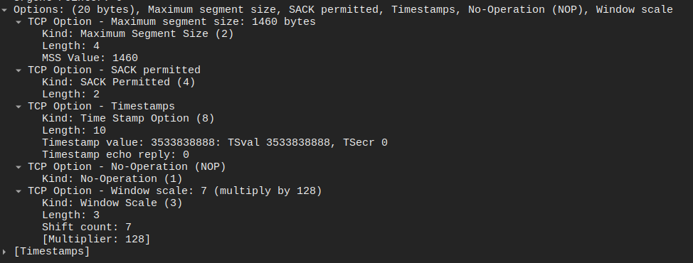
In TCP header,
Options field provide info about - MSS,Timestamp, No operation(NOP),Window scale and SACK (Selective acknowledgement)
We can see SACK Permitted

Question 4.
Ans -
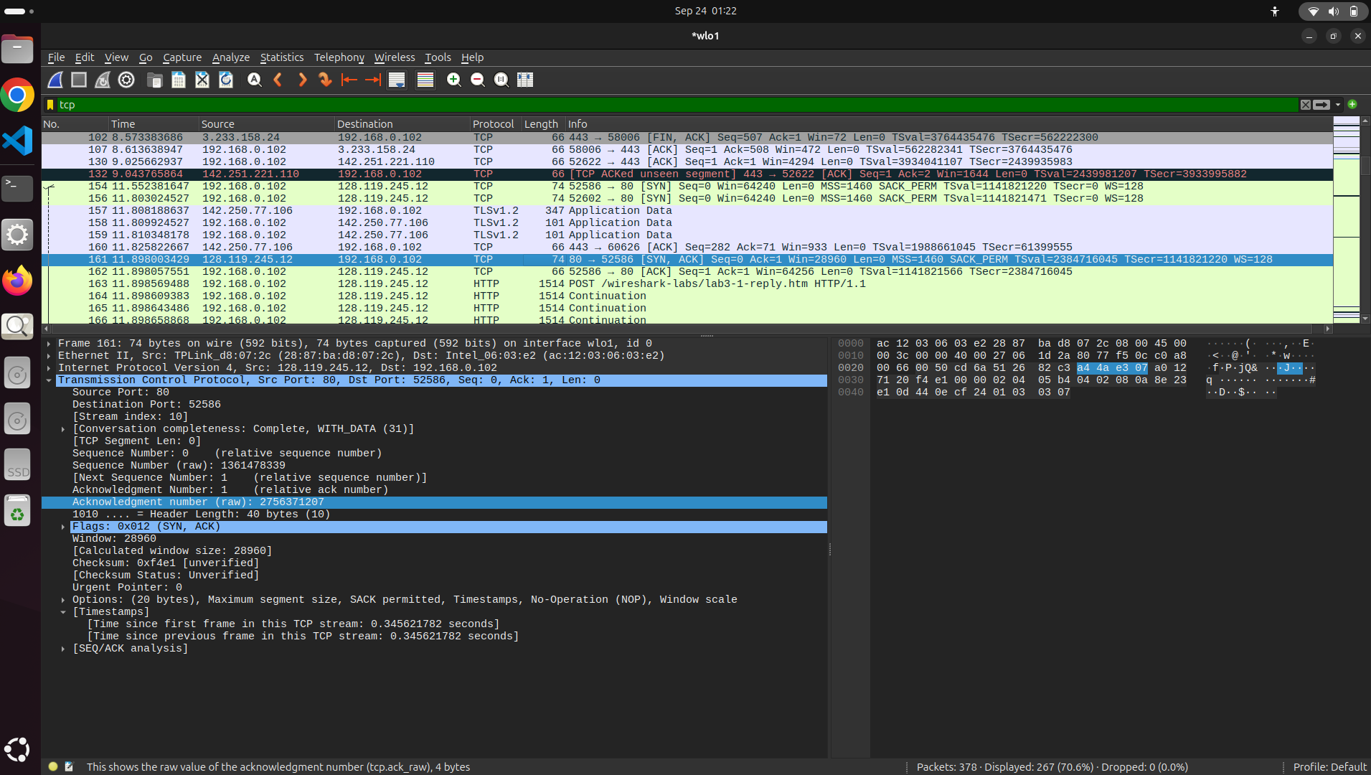
TCP - SYN ACK Segment - (Receiver to Server ) Identifies Server readiness.
Sequence Number = 0
Sequence Number (raw) = 1361478339
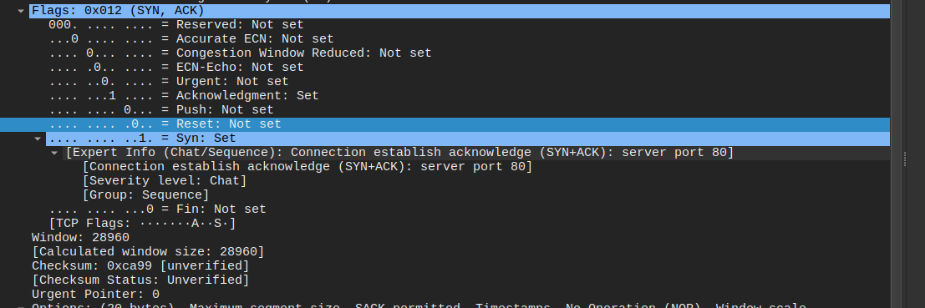
The flag fields
Flags: 0x012 (SYN ACK)
Which tells that this receiver server is ready to establish the connection.

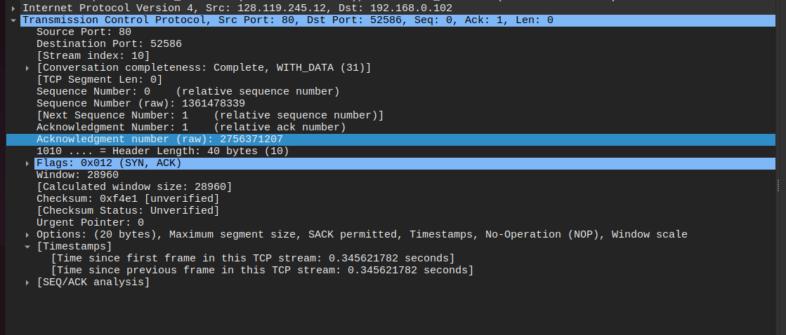
Acknowledgment Number = 1
Acknowledgment Number (raw) = 2756371207
As we know, When we send SYN segment with Sequence Number (raw) = 2756371206
So when we get Acknowledgement number from receiver we will get
Acknowledgement Number(raw) (SYN,ACK)=Sequence Number (raw)(SYN) +1
2756371207 = 2756371206 + 1
This is how the server decides what the Acknowledgement number.

Question 5.
Ans-
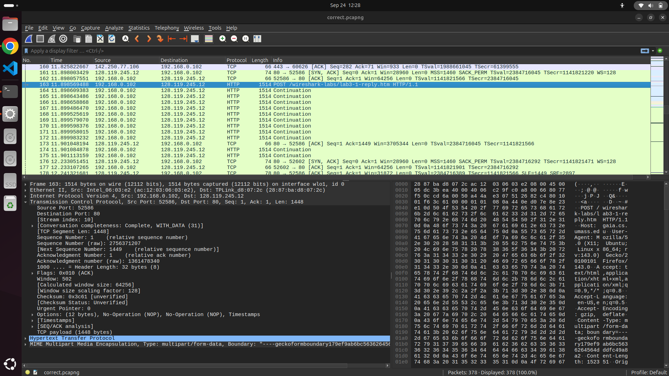
Sequence number of the TCP segment that contains the POST header =
Sequence Number (raw)=756371207
Sequence Number (Relative)=1

Number of bytes in that TCP segment’s payload (the DATA field) = 1448 Bytes
Size of alice.txt file is = 152351 Bytes
As file size > TCP payload size , the entire file can’t be sent as a single file. So answer in NO.

First Segment containing HTTP Post arrived at time = 11.898569488
ACK for this first data-containing segment received at time =11.901048194

Round Trip Time for First Segment
RTT1 = t_ack1 − t_send1 = 11.901048194 - 11.898569488 = 0.002

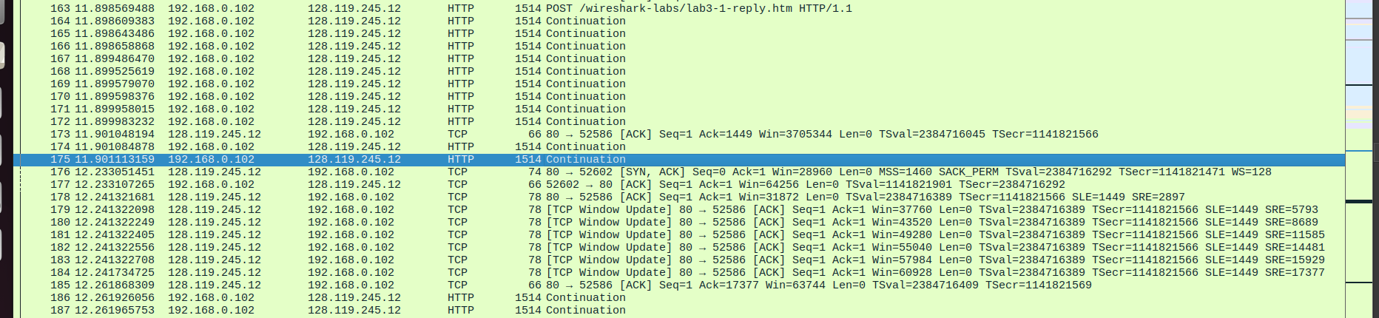
For first segment i got individual acknowledgement but from second segment i get cumulative acknowledgement for next 10 segments
Time at which last client segment whose bytes are acknowledged by that cumulative ACK = 11.901113159
Cumulative Acknowledgment time = 12.261868309 (As i am not getting ack for individual segment)
RTT2=12.261868309−11.901113159 = 0.360755150

Calculation of estimated RTT -
EstimatedRTTnew​=(1−α)⋅EstimatedRTTold​+α⋅SampleRTT
Where:
- α=0.125\alpha = 0.125α=0.125
- EstimatedRTTold=RTT1=0.002438811 s
- SampleRTT=RTT2=0.360755150 s
EstimatedRTTnew​ = (1−0.125) x 0.002438811 + 0.125 x 0.360755150 EstimatedRTTnew=0.8750 x 002438811 + 0.125 x 0.360755150
EstimatedRTTnew=0.002134159625+0.04509439375
EstimatedRTTnew= 0.047228553375 seconds

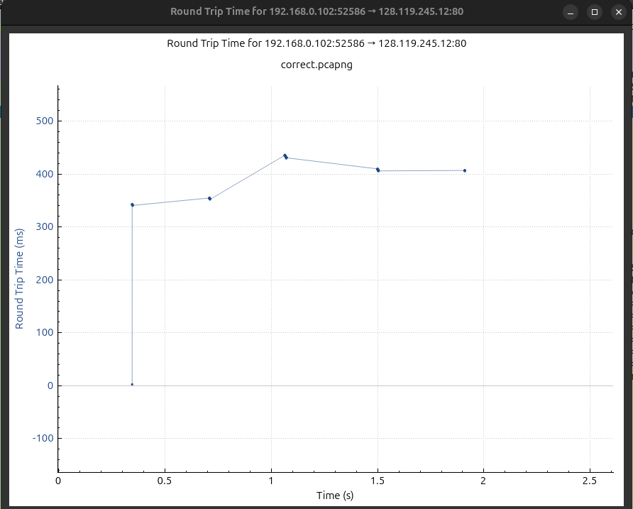

Question 6.
Ans -
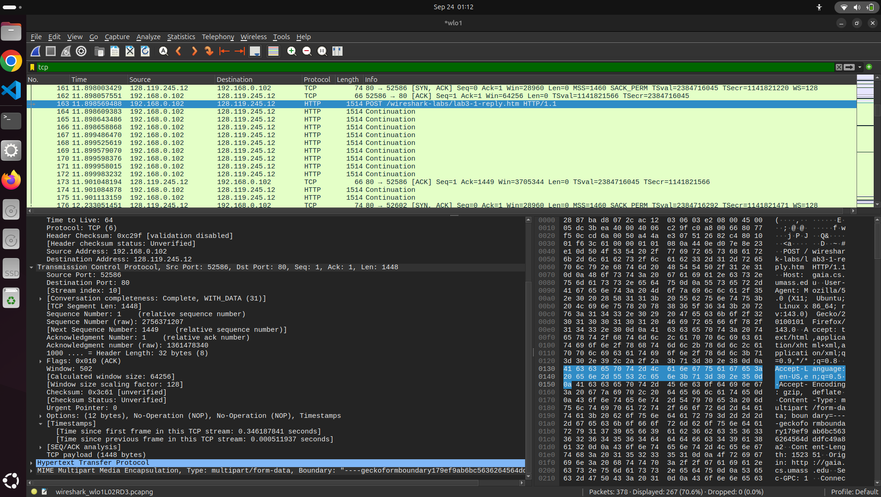

Segments | Header length | Payload length | Total
1 | 32 | 1448 | 1468
2 | 32 | 1448 | 1468
3 | 32 | 1448 | 1468
4 | 32 | 1448 | 1468

Question 7.
Ans -
All 4 segments got same Window ,Calculated Window size and Scaling Factor


Segment | Window (raw) | Scaling Factor | Calculated Window (Bytes)
1 | 28948 | 128 | 28948 × 128 = 3705344
2 | 498 | 128 | 498 × 128 = 63744
3 | 543 | 128 | 543 × 128 = 69504
4 | 566 | 128 | 566 × 128 = 72448

All four segments advertise different bytes as available buffer space to the client.

Minimum Advertised buffer size = 63744 Bytes

TCP Payload per segment = 1448 Bytes
For Four segments (Bytes in Flight)= 4 x 1448 Bytes = 5792 Bytes

Throttling occurs when:
Bytes in flight ≥ Advertised window
But in this case Bytes in flight < Advertised window
5792 < 63744 Bytes
The receiver (gaia.cs.umass.edu) advertises a window of 64,256 bytes, which is significantly larger than the total data in these segments.
The receiver buffer is plenty and the sender is not throttled for these four segments.
the sender is not throttled, and transmission can proceed without waiting for additional window updates.

Question 8.
Ans -
There is no Retransmission in My file.
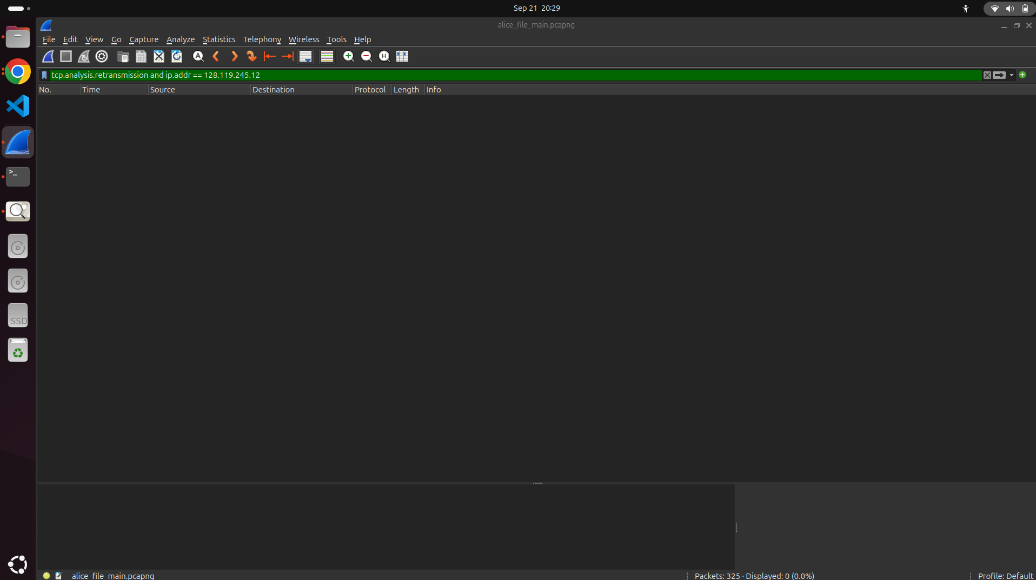

Retransmission -
A retransmission occurs when a TCP segment is sent again because the sender did not receive an ACK for that segment within the expected time (or detected a loss).

How to check -
1. We can visually inspect the sequence number in the list. If any segment has the same seq. No. is sent after that point of time before receiving ACK then that segment is re-transmitted.

2. In Wireshark we can use display filter tcp.analysis.retransmission then we can see if any packet got retransmitted or not.
3.I looked at the TCP connection's Time-Sequence Graph (Stevens) in Wireshark. No segments were retransmitted, as seen by the graph's sequence numbers of the data-carrying segments increasing steadily without any horizontal steps or repeated spots. Since this observation aligns with the trace, the recorded data does not contain any retransmissions.

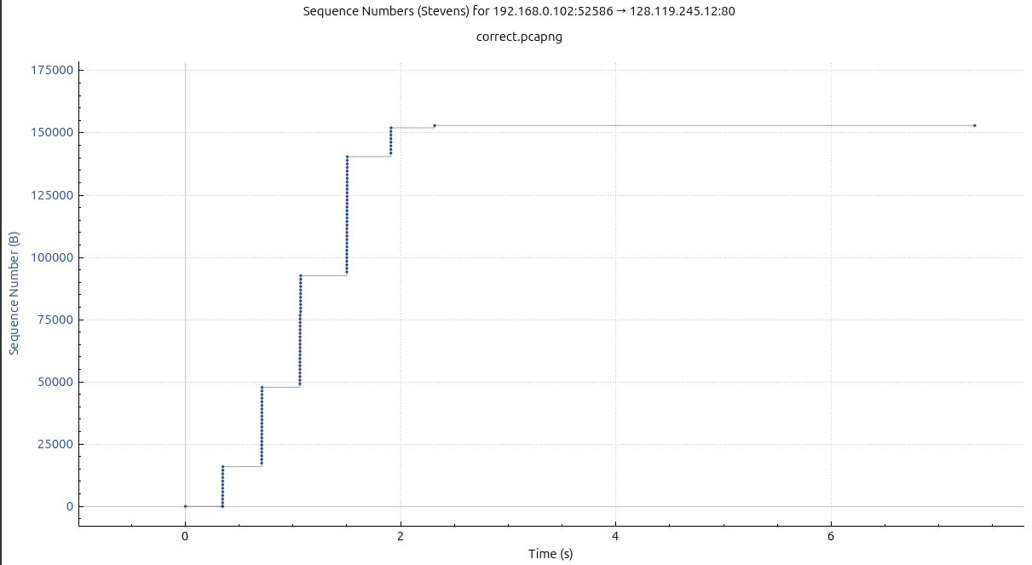

Question 9.
Ans -
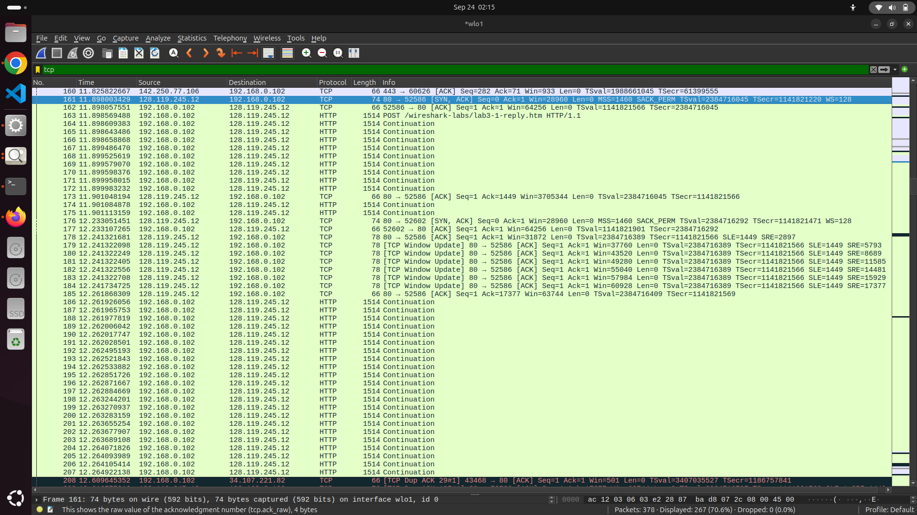
The client previously sent data from Seq=1 up to Seq=1448 (total 1448 bytes).
The server ACKed 1449, meaning it received 1448 bytes in one ACK.

Delayed ACK:
IIn my capture, I saw that the receiver only instantly recognized the first of the first ten data-carrying segments.

The receiver acknowledged all of the segments sent thus far (segments 1–10) with a cumulative ACK after transmitting two more segments.

This demonstrates delayed ACK behavior, in which the receiver waits before recognizing several segments collectively. This allows the receiver to acknowledge many segments simultaneously rather than sending an ACK for each segment separately.

Question 10.
Ans-

Consider First packet which sends data,
Time stamp for first segment = start = 11.898569488 Seconds

Consider last segment sent,
Time stamp for last segment = end = 13.462963054 Seconds
Total Time = end - start=13.462963054−11.898569488=1.564393566 seconds
Total Bytes (Size of file Alice.txt)= 152351 bytes
Throughput = Total Bytes/Total time
Throughput = 152351/1.564393566=97,700 bytes/sec

Question 11.
Ans-
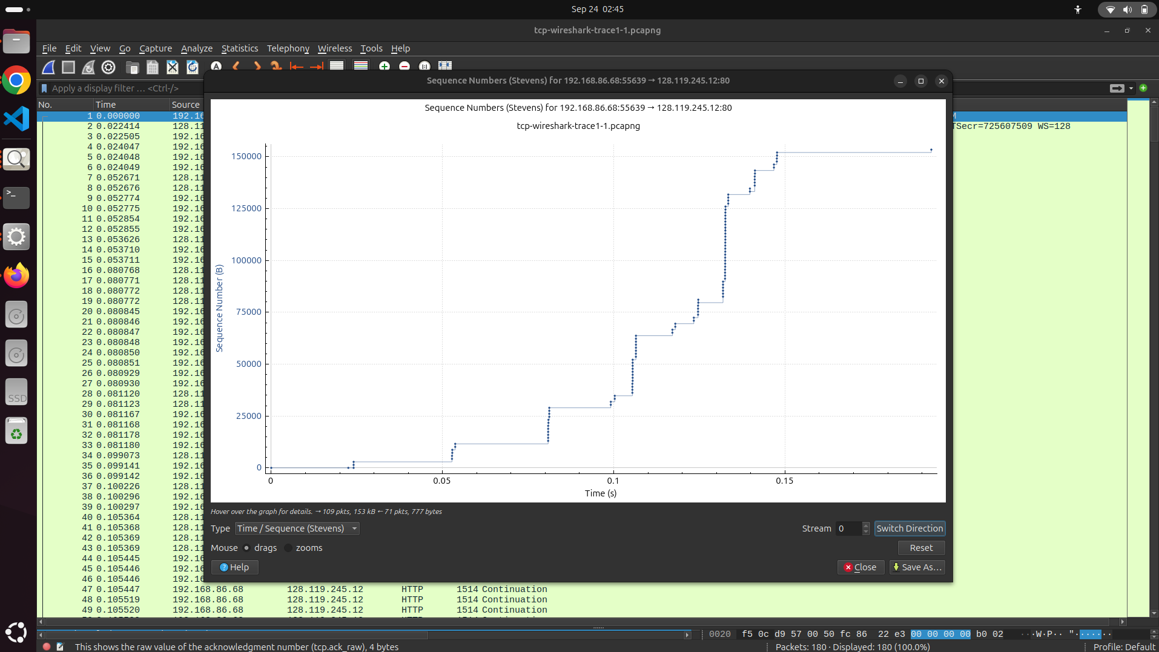
Time-Sequence (Stevens).
Exponential (bursts get bigger each RTT) → Slow Start.
Linear growth (steady slope) → Congestion Avoidance.
Flat / retransmissions → Recovery or idle.
Examining the Time-Sequence Graph,
- The fleets of packets sent at t ≈ 0.025, 0.053, 0.082, and 0.1
- Show that the vertical jumps in sequence numbers increase rapidly with each fleet.
- When the congestion window increases exponentially after each round-trip time, this pattern signifies that TCP is in its sluggish start phase. Therefore, the congestion avoidance phase has not yet been reached by the connection.

Question 12.
Ans -
- Fleet 1: t ≈ 0.025 s
- Fleet 2: t ≈ 0.053 s
- Fleet 3: t ≈ 0.082 s
- Fleet 4: t ≈ 0.1 s

We can estimate the period as the time difference between consecutive fleets:

- Period between Fleet 1 and Fleet 2: 0.053 − 0.025 = 0.028 s
- Period between Fleet 2 and Fleet 3: 0.082 − 0.053 = 0.029 s
- Period between Fleet 3 and Fleet 4: 0.100 − 0.082 = 0.018 s (Outlier)
We are ignoring small outlier.
So the approximate period of the bursts is around 0.02–0.03 seconds.

Question 13. Answer each of two questions above for the trace that you have gathered when you transferred a file from your computer to gaia.cs.umass.edu
Ans-



Repeat Question 11.
Time-Sequence (Stevens).
Exponential (bursts get bigger each RTT) → Slow Start.
Linear growth (steady slope) → Congestion Avoidance.
Flat / retransmissions → Recovery or idle.
Examining the Time-Sequence Graph,
- The fleets of packets sent at t ≈ 0.35, 0.65, 1.07, 1.5 and 1.92
- Show that the vertical jumps in sequence numbers increase rapidly with each fleet.
- This pattern indicates that TCP is in its slow start phase, where the congestion window grows exponentially after each round-trip time. So the connection has not entered the congestion avoidance phase.
- Then for 5 th we get small bursts (Decreased) suggests start of congestion avoidance.

Repeat Question 12.

- Fleet 1: t ≈ 0.35 s
- Fleet 2: t ≈ 0.65 s
- Fleet 3: t ≈ 1.07 s
- Fleet 4: t ≈ 1.50 s
- Fleet 5: t ≈ 1.92 s

We can estimate the period as the time difference between consecutive fleets:

- Period between Fleet 1 and Fleet 2: 0.65s−0.35s=0.30s
- Period between Fleet 2 and Fleet 3: 1.07s−0.65s=0.42s
- Period between Fleet 3 and Fleet 4: 1.50s−1.07s=0.43s
- Period between Fleet 4 and Fleet 5: 1.92s−1.50s=0.42s
We are ignoring small outliers.
So the approximate period of the bursts is around 0.42 seconds.

Wireless - UDP

Question 1.
Ans -
First UDP Segment -
Packet Number = 60
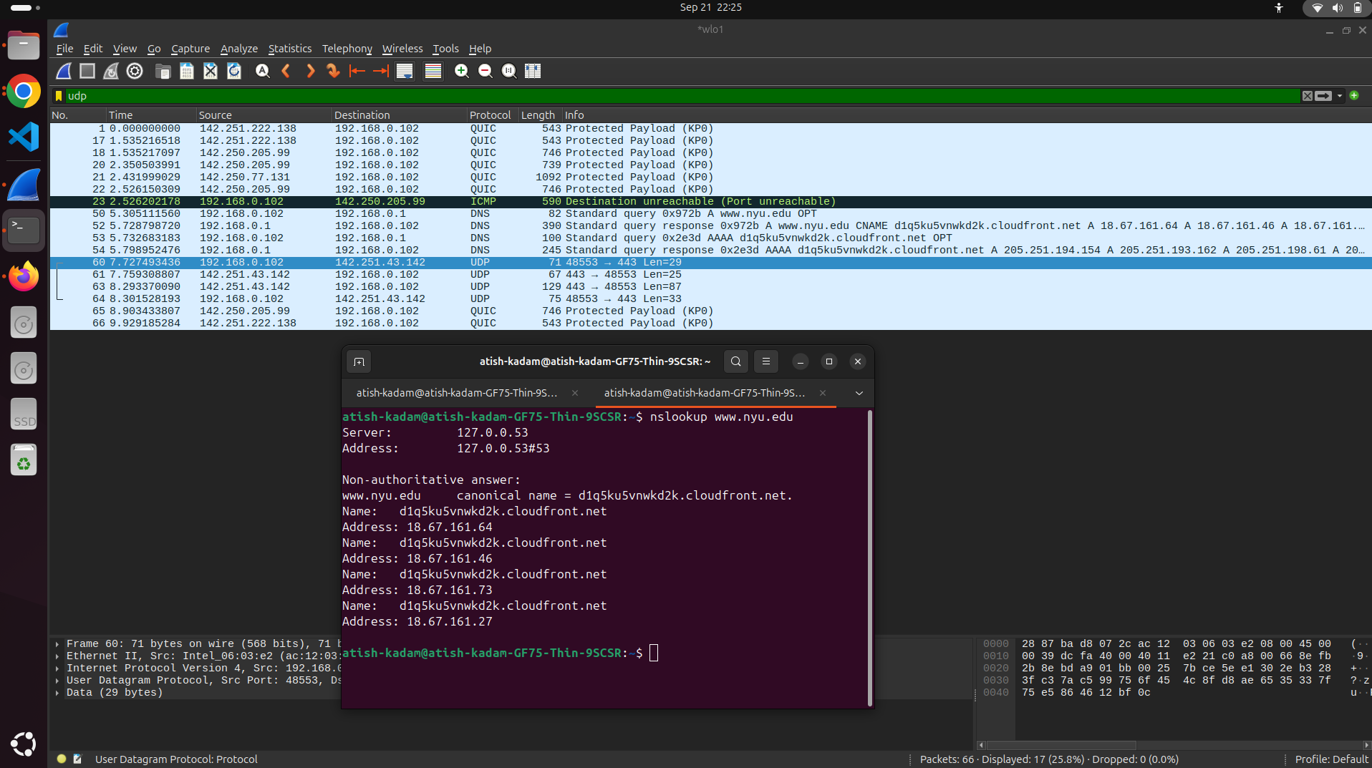

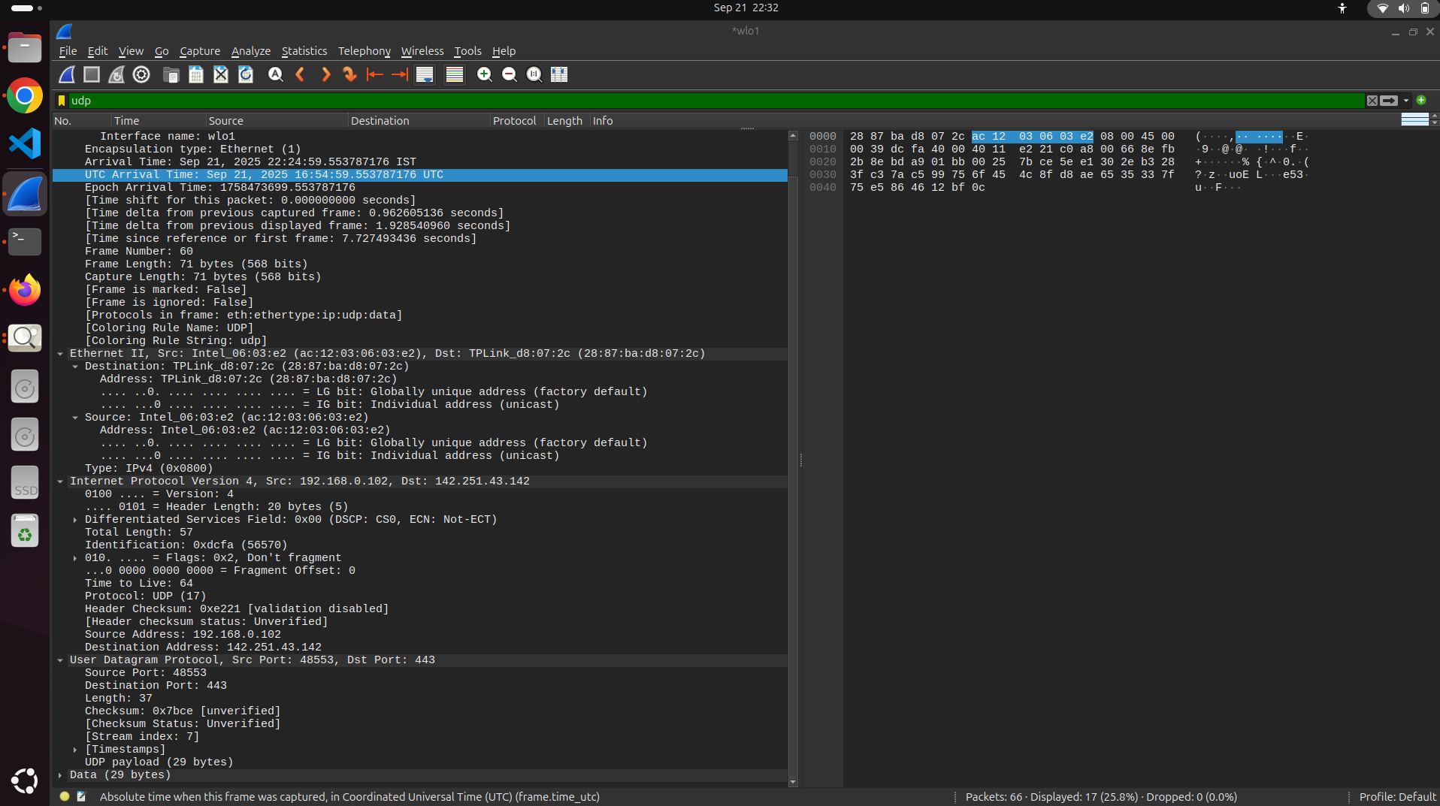

Application-layer payload/protocol carried:

29 bytes of raw data are carried by the UDP segment to port 443. Wireshark marks port 443 as "Data" since no standard protocol is applicable, even though it is often used for HTTPS over TCP. In this case, the port is just used for generic UDP data.

Number of fields in the UDP header:
From our observation of wireshark, there are 4 fields.

UDP header Fields:
- Source Port - 48553
- Destination Port - 443
- Length - 37
- Checksum - 37

Question 2.
Ans -
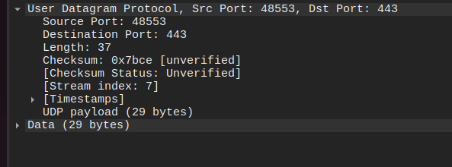
Size of UDP is header is always 8 Bytes.
Size of each field is fixed.
Here are the correct lengths of each field:
  - Source Port: 2 bytes (16 bits)
  - Destination Port: 2 bytes (16 bits)
  - Length: 2 bytes (16 bits)
  - Checksum: 2 bytes (16 bits)
Each field = 2 bytes long
Total UDP header length = 8 bytes
Question 3.
Ans -
UDP Length field = Total length of the UDP datagram in Bytes
UDP Header size = Sum of size of All UDP fields
UDP Length Field = UDP Header size+ UDP payload

Now check for Frame 60:
UDP Length field (from Wireshark) = 37 bytes.
UDP payload = 29 bytes.
UDP header (fixed) = 8 bytes.

UDP Length=UDP header+UDP payload=8+29=37
My claim is verified.

Cross-check with IP and Ethernet fields (consistency check):

IP Total Length (in the IPv4 header) = 57 bytes (given in the packet).
IPv4 Total Length = IP header (20 bytes) + UDP datagram (37 bytes) →
IPv4 Total Length=57
57=37+20

Frame Length on the wire = 71 bytes.
Ethernet frame = Ethernet header (14 bytes) + IP total (57 bytes) →
14+57=71

Question 4.
Ans -
The UDP header contains a
Length Filed = 16 bits
Since the Length field is 16 bits,
Max value possible = 2^16 -1= 65,535 bytes. This value includes both the UDP header and the UDP payload.

Because the UDP header is always 8 bytes long, the maximum size of the payload is:

65,535 bytes (maximum total)} - 8 bytes (header) = 65,527 Bytes

Maximum possible size of UDP payload is 65,527 bytes

Question 5.
Ans -
The Source Port field in the UDP header is 16 bits long.
The maximum value a 16-bit field can represent is = (2^16) - 1 = 65,535
Therefore, the largest possible source port number is 65,535*.

Question 6.
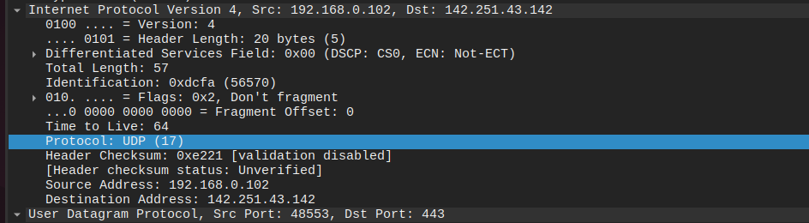
If we check in IPV4 datagram header,
Protocol Fileds - Transport layer Protocol carried in the payload.
17-UDP 6-TCP 1-ICMP
In my observation i got (Frame 60):
Protocol: UDP (17)`

Question 7.
Ans -
Packet Number - 60 from Host to Server and 61 from server to host as reply.
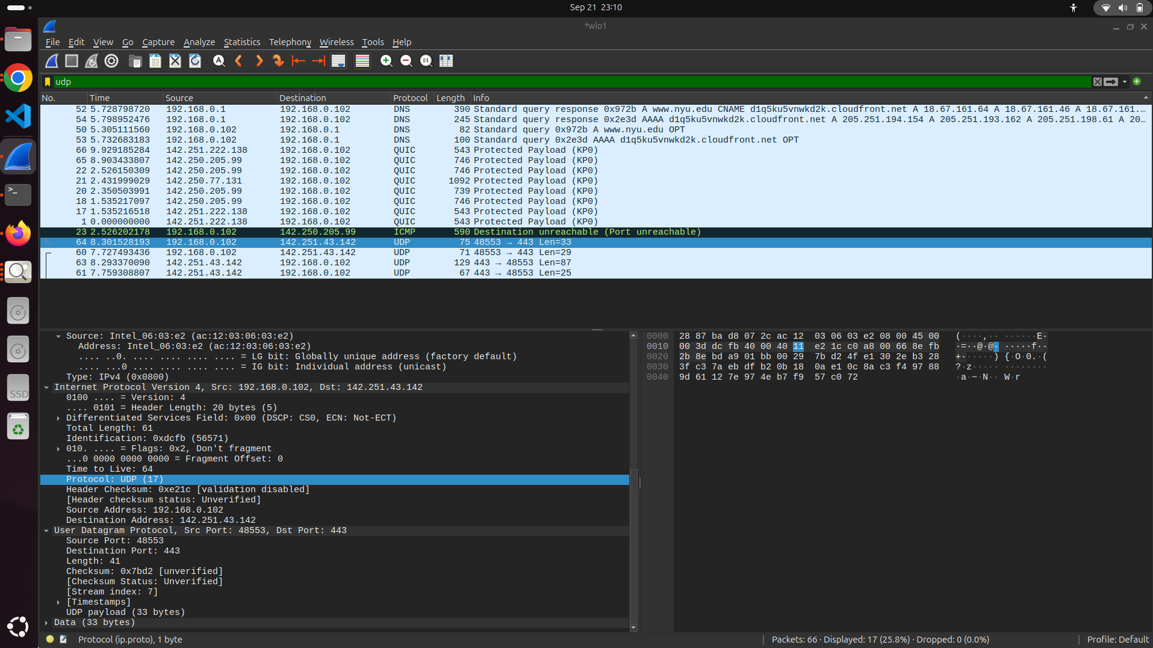
UDP Packet Pair Analysis

First UDP Packet (sent by your host):
- Packet Number: 60
- Source Port: 48553
- Destination Port: 443

Second UDP Packet (reply from the server):
- Packet Number: 61
- Source Port: 443
- Destination Port: 48553

Relationship between the port numbers:

- In the reply, the source port (48553) of the initial packet is used as the destination port.
- The reply's source port is the initial packet's destination port (443).
- This demonstrates the typical UDP client-server communication, in which the client sends data using an ephemeral port and the server replies using its familiar port.

Links to my capture https://drive.google.com/drive/folders/14aCa5z7RINaAEWZaMGob69Xy2Hgi14yZ?usp=sharing
Disclaimer and Acknowledgment

Student Name: Atish Kadam
Student ID: CS25MTECH14003
Signature: 